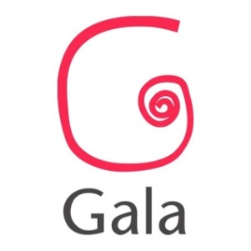
NEXT UP… Application Form
Next Up… is Gala’s stage for new work by regional theatre makers. The event provides an opportunity for playwrights, artists or companies to test and share new work in front of a friendly and constructive audience. It’s a chance for you to road-test new work and gather feedback; it’s also the best way for the team at Gala to get to know you and your work.
We encourage submissions in a wide range of genres and styles of performance. Each Next Up… event will feature four original work-in-progress pieces.
Application Guidelines
- Applicants must be based in the North of England
- Work can be stand-alone or an excerpts from a longer piece
- Performed excerpts should be no longer than 20 minutes
- All actors / performers must be provided by the participating company / artist / writer.
- Your performance should be possible to stage with minimal props. Sound and lighting requirements must be suitable for performance in a small, studio style space
- All applications must be submitted electronically no later than 6 weeks prior to the event.

Name

Company Name

Title of piece (please state if working title)

Number of Performers

Contact Number

Contact Email

Website (if relevant)

Tell us about your work / practise (no more than 200 words)

Tell us about the work you would like to share at Next Up… (no more than 200 words)

Marketing Copy (100 words max)

Tech requests: what do you need and will you be bringing / providing?

Additional information (health and safety, age restrictions, hazards etc):

Feedback: What questions would you like to ask the audience at Next Up…? (Don’t worry if you don’t know this yet, we will ask successful applicants again on selection)

Thank you for your interest in Next Up…
Please return this form to Rory.Stuart@durham.gov.uk

