Art Durham – outdoor art exhibition

Durham County Council and Durham University are working together to develop a new two week contemporary visual arts festival Art Durham (5th to 17th June 2018) which will feature a wide range of visual arts activity appealing to a variety of audiences from families to students and arts professionals. The festival will also feature a pop up Outdoor Selling Art Exhibition along the riverside below Millennium Place on 16th and 17th June between 10am and 4pm.There will be in total forty heras fencing panels (3.5mx 2m) on which artists can display 2D work. A small charge of £20 per artist, per panel, will be made for using the display space for two days. A small canopy will be attached to the fencing panel to protect against rain.

We will be producing an artist designed map showing all visual arts activity as well as other advertising and marketing material to promote the festival and exhibition.
Submission
We are inviting artists from across the North East to apply to be part of the Outdoor Art Exhibition. We are looking for artists to exhibit original artwork that will be available for sale. No additional commission will be charged above the £20 hire fee.
Please complete the attached application and send it together with up to four images of your work by email to GalaGallery@durham.gov.uk by 30 April 2018 5pm. Successful candidates will be informed by 14 May 2018.

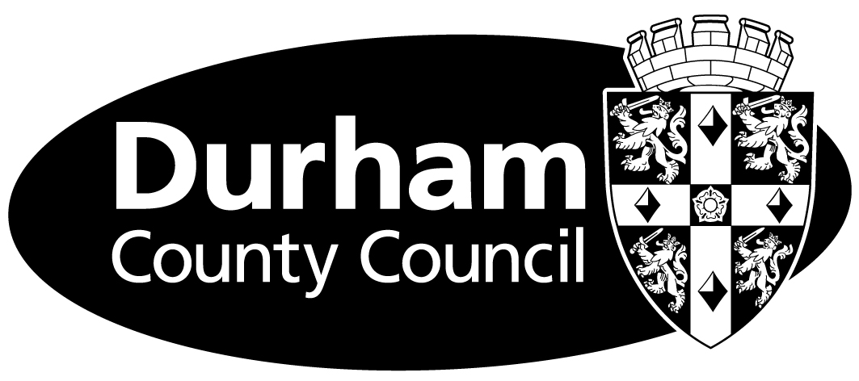

Application Form
Name
Address | Postcode:
Email
Telephone

Description of your work (50 words)

Please attach to your application up to 4 images or weblinks showing your work.

Please email your application to Lucy Jenkins at galagallery@durham.gov.uk by 5pm on 30 April 2018. Please put Outdoor Art Exhibition in the email subject line.

